Southern Georgia Regional Commission
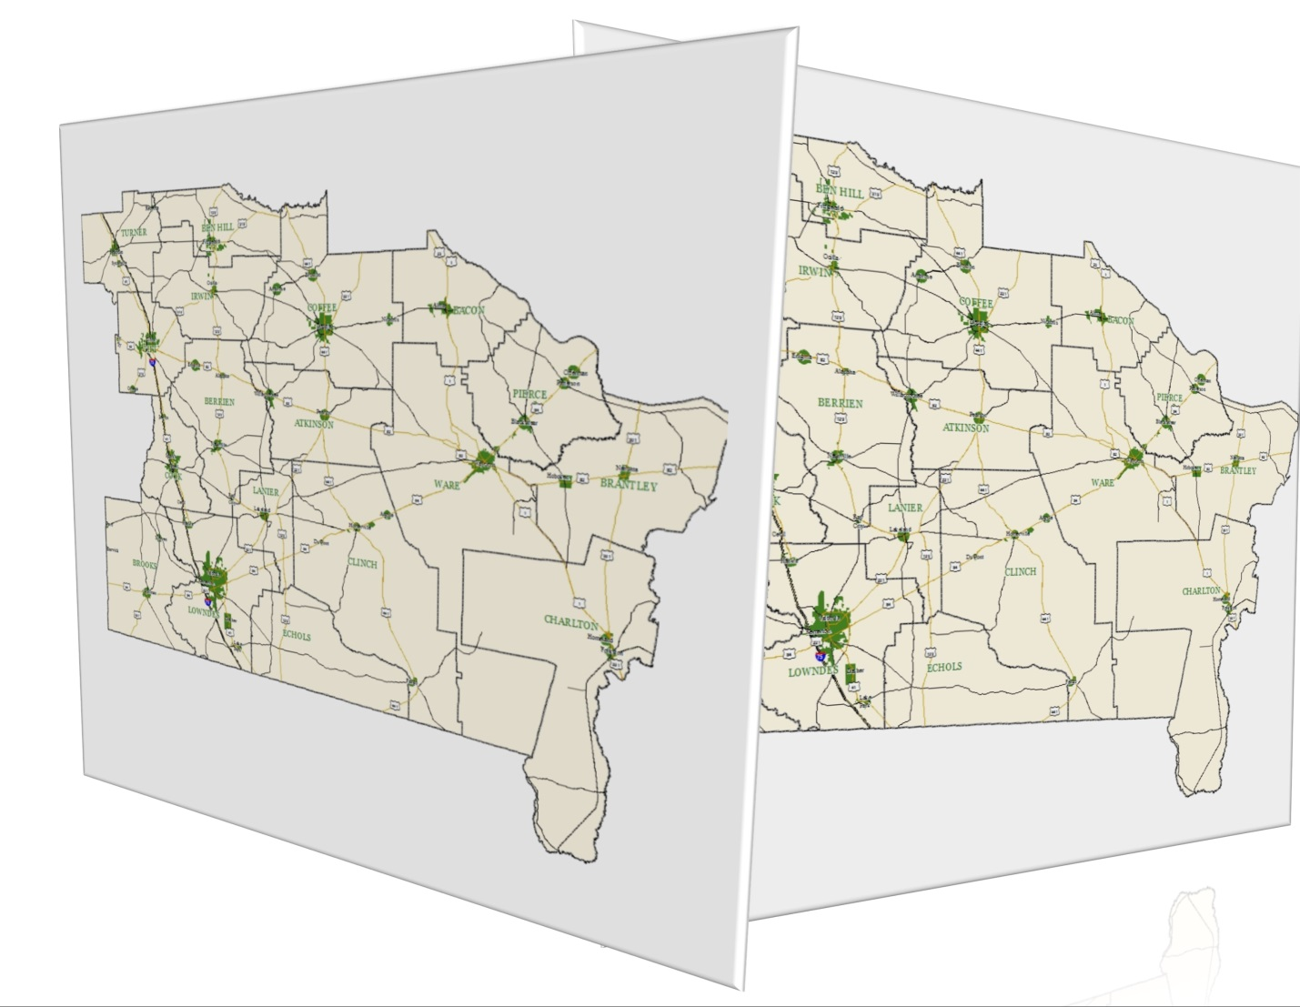
Regional Work Program Annual Update
Draft
March 24, 2016

blank
Table of Contents
Contents
Regional Work Program Report of Accomplishments 5
Economic Development – Regional Work Program Report of Accomplishments FY 2016 - 2020 6
Natural and Cultural Resources – Regional Work Program Report of Accomplishments FY 2016 - 2020 7
Community Facilities & Services – Regional Work Program Report of Accomplishments FY 2016 - 2020 9
Housing – Regional Work Program Report of Accomplishments FY 2016 - 2020 11
Land Use – Regional Work Program Report of Accomplishments FY 2016 - 2020 13
Transportation – Regional Work Program Report of Accomplishments FY 2016 to 2020 14
Intergovernmental Coordination – Regional Work Program Report of Accomplishments FY 2016 to 2020 15
Education – Regional Work Program Report of Accomplishments FY 2016 - 2020 17
Regional Work Program Update 18
Economic Development – Regional Work Program Update FY 2017 - 2021 19
Natural and Cultural Resources – Regional Work Program Update FY 2017 - 2021 20
Community Facilities & Services – Regional Work Program Update FY 2017 - 2021 21
Housing – Regional Work Program Update FY 2017 - 2021 22
Land Use – Regional Work Program Update FY 2017 - 2021 23
Transportation – Regional Work Program Update FY 2017 to 2021 24
Intergovernmental Coordination – Regional Work Program Update FY 2017 to 2021 25
Education – Regional Work Program Update FY 2017 - 2021 26
Senior Services/Aging - Regional Work Program Update FY 2017 - 2021 27
Areas Requiring Special Attention Update 28
Areas of Significant Natural and Cultural Resources 29
Developing areas in eastern Brantley County along the Satilla River and Glynn County Line. 29
GA 121 – from Folkston city limits south to the Florida border. 30
Areas of Rapid Development 31
Douglas Perimeter. 31
Bacon County Blueberry Plantation. 32
Ben Hill County Airport/Industrial Area and South Corridor. 33
Troupeville Community. 34
Western Lanier County/Banks Lake NWR. 35
Downtown Waycross. 36
Areas of Significant Disinvestment 37
Oak Park Deterioration. 37
Military Installation – Moody Air Force Base and Surrounding Area 38
Moody Activity Area. 38
Evaluation and Monitoring 39
Evaluation & Monitoring Activities from July 1, 2015 to Present 39
3 year Evaluation & Monitoring of Local Government Performance Measures 40
Local Government/Stakeholder Survey-Interview-Visit Dates 47

Regional Work Program Report of Accomplishments
1. The Southern Georgia Regional Commission completed and adopted its Regional Plan in April 2013. The following document contains the annually required update to the Regional Work Program, including the report of accomplishments, the update to the previous years’ work program, and the evaluation and monitoring report.
Regional Commission staff reviewed the previous year’s (2015) Regional Work Program and for the Report of Accomplishment classified all activities into the following categories:
Have been Completed
Are Currently Underway (including a completion date)
Have been Postponed
Have not been accomplished and are no longer activites intended to be undertaken.
SGRC has added a fifth category for its Update:
On Schedule (for those projects which have not been started, but which are on schedule)
In the following two tables, Report of Accomplishments and Regional Work Program Update,
*P & C refer to planning and coordination activities; and * R refers to review activities.

Economic Development – Regional Work Program Report of Accomplishments FY 2016 - 2020
ACTIVITY | P&C  Or  R* | TIME FRAME  Year July 1, 2015 – June 30, 2020 |  |  |  |  |  | ESTIMATED COST (annual) | FUNDING SOURCE(S) | ISS/OPP ADDRESSED | ROA
 |  | current | 2016 | 2017 | 2018 | 2019 | 2020
Collaborate on the creation of Digital Economy Incubators – request by regional leaders | P&C | x | x |  |  |  |  | Staff Time  $35,000 | DCA, Local Governments | ED: I-1, I-5, I-6, O1-5, O-6 | Postponed  – no funding this fiscal year
Transportation Planning  to Support Economic Development: An Exploratory Study of Competitive Industry Clusters and Transportation | P&C | x | x |  |  |  |  | Staff Time  $150,000 | DCA, MPO, local governments | ED: I-1, I-5, I-6, O1-5, O-6 | completed
Develop a Moody Air Force Base Cooperation plan on encroachment – request by regional leaders | P&C |  | x | x |  |  |  | Staff Time  $25,500 | DCA, Local Governments, EDA, MPO | ED: I-1, O-1, O-4, O-5 NC: O-3, O-4, I-3, I-5; IC: I-3  E: O-1, O-2, O-3 | currently underway – completed for Lanier County and Lowndes/Valdosta
GIS Inventory of infrastructure in the region such as water, sewer, natural gas, and broadband – request by regional leaders | P&C | x |  |  |  |  |  | Staff Time  $30,000 | DCA, EDA | I-3, I-5 | currently underway– no completion date as these projects are offered on a case by case basis
Provide Grants Writing Assistance to local Government for grants that promote economic development | P&C  R | x | x | x | x | x | x | Staff Time  $5,000 | DCA, Local Governments, EDA | ED: I-5, I-6  LU: O-1, O-7 | currently underway – no completion date as these projects are offered on a case by case basis
Review/Write Economic Development Elements for local government comprehensive plan updates: , Clinch ,Turner, Ben Hill, Lanier, Brantley, Ware, Lowndes Counties and their Cities | P&C  R | x | x | x |  |  |  | Staff Time  $5,000/element | DCA/ Local Governments | ED: I-5  LU: O-1  E: I-1 | completed
Develop a region-wide attractions map as part of a tourism brochure in GIS format to highlight tourism attractions and events in the region | P&C |  | x | x |  |  |  | Staff Time  $10,000 | DCA, MPO | ED: I-1, I-5, I-6, O1-5, O-6 | completed in phases – bicycle route maps through various areas of the region

Natural and Cultural Resources – Regional Work Program Report of Accomplishments FY 2016 - 2020
ACTIVITY | P&C  Or  R* |  |  | TIME FRAME  Year July 1, 2015 – June 30, 2020 |  |  |  |  |  |  |  |  |  |  |  |  |  |  |  |  |  |  | ESTIMATED COST  (annual) |  |  | FUNDING SOURCE(S) |  |  | ISS/OPP ADDRESSED |  |  |  | ROA
 |  |  |  | current |  |  | 2016 |  |  |  | 2017 |  |  | 2018 |  |  | 2019 |  |  | 2020
Update the Regional Important Resource Plan incl. marketing plan | P&C |  |  |  |  |  |  |  |  |  | x |  |  | x |  |  |  |  |  |  |  |  | $65,000  Staff Time |  |  | DCA, Local Governments |  |  | NC: I-1, I-2, O-1, O-3, O-4 |  |  |  | on schedule as planned
Develop a regional land bank program – request by regional leaders | P&C |  |  |  |  |  | x |  |  |  |  |  |  |  |  |  |  |  |  |  |  |  | $50,000  Staff Time |  |  | DCA, Local Government |  |  | NC: O-2 |  |  |  | not been accomplished and no longer intended – loss of interest in the region for a regional land bank in favor of local land banks
Assist Local Governments with obtaining information on Federal and State Tax Credits, Incentives & Innovative Financing for historic preservation projects | P&C  R |  |  | x |  |  | x |  |  |  | x |  |  | x |  |  | x |  |  | x |  |  | $2,000 staff time |  |  | DCA, Local Governments |  |  | NC: I-5, O-5 |  |  |  | currently underway
Develop a Stormwater Ordinance Template for use by local governments – request by regional leaders | P&C |  |  |  |  |  | x |  |  |  |  |  |  |  |  |  |  |  |  |  |  |  | $10,000 |  |  | DCA, local Governments |  |  | NC: I-1, I-2, O-1, O-3, O-4 |  |  |  | postponed due to lack of funding; MPO is now required by federal law to assist communities, so project will be continued for new work program.

Community Facilities & Services – Regional Work Program Report of Accomplishments FY 2016 - 2020
ACTIVITY |  |  | P&C  Or  R* |  |  | TIME FRAME  Year July 1, 2015 – June 30, 2020 |  |  |  |  |  |  |  |  |  |  |  |  |  |  |  |  |  | ESTIMATED COST (annual) |  |  | FUNDING SOURCE(S) |  |  | ISS/OPP ADDRESSED |  |  |  | ROA
 |  |  |  |  |  | current |  |  | 2016 |  |  | 2017 |  |  | 2018 |  |  | 2019 |  |  | 2020
Create a regional stormwater master plan that addresses water quantity and quality and flood plain management – request by regional leaders |  |  | P&C |  |  |  |  |  |  |  |  | x |  |  | x |  |  |  |  |  |  |  |  | $45,000 |  |  | DCA, Local Governments |  |  | N/C: I-1, I-4, I-5; O-1 |  |  |  | on schedule
Administer grants for Local Communities on request, specifically CDBG grants, and encourage infrastructure projects for water, sewer, natural gas and broadband |  |  | P&C  R |  |  | x |  |  | x |  |  | x |  |  | x |  |  | x |  |  |  |  |  | $5,000  Staff Time |  |  | DCA, EDA, Local Governments |  |  | CFS: I-1, I-2, I-4, I-5 |  |  |  | currently underway – completion 2020
Develop a Post-Disaster Response Plan for Business Communities – request by regional leaders |  |  | P&C  R |  |  |  |  |  |  |  |  |  |  |  | x |  |  | x |  |  |  |  |  | $50,000 |  |  | DCA, Local Governments, FEMA |  |  | N/C: O-1 |  |  |  | on schedule
Create GIS Facilities Maps for broadband and inventory connection speeds and service providers for all community anchor institutions – request by regional leaders |  |  | P&C |  |  | x |  |  | x |  |  |  |  |  |  |  |  |  |  |  |  |  |  | $35,000 |  |  | DCA, local Governments |  |  | I-4 |  |  |  | not accomplished – funding not available
Review/Write Community Work Programs for Local Governments as part of their Comprehensive Plan Updates: Clinch, Turner, Ben Hill, Lanier, Brantley, Ware and Lowndes Counties and their cities |  |  | P&C  R |  |  | x |  |  | x |  |  |  |  |  |  |  |  |  |  |  |  |  |  | $7,500 each |  |  | DCA, local Governments |  |  | O-1, O-2 |  |  |  | complete; Lowndes is underway with completion in FY 2017

Housing – Regional Work Program Report of Accomplishments FY 2016 - 2020
ACTIVITY |  | P&C  Or  R* |  |  | TIME FRAME  Year July 1, 2015 – June 30, 2020 |  |  |  |  |  |  |  |  |  |  |  |  |  |  |  |  | ESTIMATED COST  (annual) |  |  | FUNDING SOURCE(S) |  |  | ISS/OPP ADDRESSED |  |  | ROA
 |  |  |  |  | current |  |  | 2016 |  | 2017 |  |  | 2018 |  |  | 2019 |  |  | 2020
Develop a model demolition template to remove condemned houses in order to improve local housing stock. – request by regional leaders |  | P&C |  |  |  |  |  |  |  | x |  |  | x |  |  |  |  |  |  |  |  | Staff Time  $20,000 |  |  | DCA, Local Governments |  |  | H: I-1, I-2, I-3, I-4, O-3 |  |  | on schedule
Co-sponsor private/public educational workshops and other programs including a revolving loan program for potential homeowners that will improve homeownership rates in the community. – request by regional leaders |  | P&C |  |  | x |  |  | x |  | x |  |  | x |  |  | x |  |  | x |  |  | Staff Time  $10,000 |  |  | DCA, Local Governments |  |  | H: I-1  LU: I-2 |  |  | not accomplished – no funding available on a regional basis, however we will assist the City of Valdosta if requested as a part of its Local Comprehensive Plan which now includes a housing element
Develop a model ordinance to assist homeowners in the maintenance and upkeep of homes and properties to avoid/minimize blight. – request by regional leaders |  | P&C |  |  |  |  |  | x |  | x |  |  |  |  |  |  |  |  |  |  |  | Staff time  $2,500 |  |  | DCA, Local Governments |  |  | H: I-4, I-5, O-5 |  |  | currently underway – completion date expected FY 2017
Develop a housing compatibility study for areas around business nodes and corridors – request by regional leaders |  | P&C |  |  |  |  |  |  |  |  |  |  |  |  |  | x |  |  |  |  |  | $35,000 |  |  | DCA, Local Governments |  |  | I-3, I-4, I-5 |  |  | on schedule
Review Local Government Housing Elements for local Comprehensive Plan Updates and provide technical assistance in the preparation as requested City of Valdosta |  | P&C  R |  |  | x |  |  |  |  |  |  |  |  |  |  |  |  |  |  |  |  | $5,000 each |  |  | DCA, Local Governments |  |  | I-3, I-4, I-5 |  |  | currently underway to be completed October 2016

Land Use – Regional Work Program Report of Accomplishments FY 2016 - 2020
ACTIVITY | P&C  Or  R* | TIME FRAME  Year July 1, 2015 – June 30, 2020 |  |  |  |  |  | ESTIMATED COST  (annual) | FUNDING SOURCE(S) | ISS/OPP ADDRESSED | ROA
 |  | current | 2016 | 2017 | 2018 | 2019 | 2020
Develop and Implement a GIS Technical Assistance and Education Program for local governments – request by regional leaders | P&C | x | x |  |  |  |  | $100,000  (total) | DCA, Local Governments | LU: I-4, O-3, CFS: O-2 ED: I-1 | currently underway – ongoing as technology develops
Review/Write Land Use Elements for local comprehensive plan updates as requested: Clinch, Ben Hill, Turner, Lanier, Brantley, Ware, Lowndes Counties and their cities | P&C  R | x | x |  |  |  |  | $7,500 each | DCA, Local Governments | LU: O-4, I-5, I-3 | completed; Lowndes County and Cities completion October 2016
Facilitate visioning workshops throughout the Region to develop regional & local identities – request by regional leaders | P&C  R | x | x | x | x | x | x | $5,000 each | DCA, Local Governments | I-1, O-1, O-3,  IC: O-1 | currently underway as funding permits; no completion date - ongoing
Develop a GIS application for Land Use to site different characteristics such as conservation, affordable housing, lots suitable for industrial development, etc. – request by regional leaders | P&C  R | x | x |  |  |  |  | $35,000 | DCA, Local Governments | LU: I-4, O-3, CFS: O-2 ED: I-1 | Postponed due to lack of funding
Provide Training workshops on planning and zoning related topics including building inspection/construction – requested by regional leaders | P&C | x |  | x |  | x |  | Staff Time  $15,000 | DCA, Local Governments | LU: O-6 | completed for 2016

Transportation – Regional Work Program Report of Accomplishments FY 2016 to 2020
ACTIVITY | P&C  Or  R* | TIME FRAME  Year July 1, 2015 – June 30, 2020 |  |  |  |  |  | ESTIMATED COST  (annual) | FUNDING SOURCE(S) | ISS/OPP ADDRESSED | ROA
 |  | current | 2016 | 2017 | 2018 | 2019 | 2020
Review/Write Transportation Elements for local comprehensive plan updates incl. ROW plans: Lowndes County and its Cities | P&C  R | x | x |  |  |  |  | $35,000 each | DCA, Local Governments, GDOT | T: I-4, O-1, O-4, O-6 | complete; Lowndes County and its cities expected completion Oct 2016
Provide technical assistance with airport planning and marketing: Cook, Charlton | P&C |  |  | x |  |  |  | Staff Time  $15,000 | DCA, Local Governments, GDOT, FAA | T: O-2 ED: O-4 LU: O-2 | on schedule
Develop a study to determine the needs of seniors in the Region regarding transportation in coordination with land use (housing, recreation, access to health facilities etc.) – requested by regional leaders | P&C  R |  |  | x |  |  |  | Staff Time  $25,000 | DCA, Local Governments, GDOT, EDA | LU: I-2, O-5, O-6 | on schedule
Develop a study to determine feasibility and strategies of enhancing railroad and airport facilities through complementary surrounding land uses. – requested by regional leaders | P&C  R |  |  |  | x |  |  | Staff Time  $40,000 | DCA, Local Governments, GDOT, EDA | LU: O-2 | on schedule

Intergovernmental Coordination – Regional Work Program Report of Accomplishments FY 2016 to 2020
ACTIVITY | P&C  Or  R | TIME FRAME  Year July 1, 2015 – June 30, 2020 |  |  |  |  |  | ESTIMATED COST  (annual) | FUNDING SOURCE(S) | ISS/OPP ADDRESSED | ROA
 |  | current | 2016 | 2017 | 2018 | 2019 | 2020
Develop/Review Comprehensive Plan and Short Term Work Programs for local Governments as required by 110-12-1-.01 or requested by Local Govts.: Clinch, Turner, Ben Hill, Lanier, Brantley, Ware, Lowndes and their Cities | P&C  R | x | x |  |  |  |  | $15,000 per plan | DCA | IC: I-1, O-1, O-3 | complete; Lowndes County and its cities completion expected October 2016
Foster coordination with the School Boards of the region, specifically with regard to school sitings, closings, conversions, and transportation issues | P&C | x | x | x | x | x | x | Staff Time  $10,000 | DCA, Local Governments | IC: I-2, O-5  CFS: O-2 | currently underway; no completion date, this is a continuing effort
Maintain the Regional Information Sharing Center and enhance function as a regional clearinghouse for networking, information sharing and project collaboration. | P&C | x | x | x | x | x | x | $5,000 | DCA, Local Governments | IC: I-1, O-4 | currently underway; no completion date, this is a continuing marketing and public information effort
Assist as requested with the Service Delivery Strategies – requested by regional leaders: Clinch, Turner, Ben Hill, Lanier, Brantley, Ware, Lowndes Counties and their municipalities | R | x | x | x | x | x | x | Staff Time | DCA, Local Governments | IC: I-1, O-1, O-3 | completed; Lowndes and its cities completion expected October 2016

Education – Regional Work Program Report of Accomplishments FY 2016 - 2020
ACTIVITY | P&C  Or  R | TIME FRAME  Year July 1, 2016 – June 30, 2021 |  |  |  |  |  | ESTIMATED COST | FUNDING SOURCE(S) | ISS/OPP ADDRESSED | ROA
 |  | current | 2016 | 2017 | 2018 | 2019 | 2020
Provide one workshop a quarter to local School Boards and other community leaders on Best Management Practices including school sitings, Planning & Zoning, Land Use/Transportation – requested by regional leaders | P&C | x | x | x | x | x | x | $10,000 | DCA, Local Governments | IC: O-4  E: I-2; O-2 | currently underway – as requested, no completion date these projects will be offered on an ongoing basis
Establish a Clearinghouse for exchange and dissemination of information to enhance cooperation and coordination within the Region. – requested by regional leaders. | P&C | x |  |  |  |  |  | 5,000 | DCA, local governments | IC: O-1  E: I-2; O-2 | Postponed due to lack of funding, in the meantime combined with the Regional Information Sharing Center

Regional Work Program Update

The projects in the Regional Work Program Update are those activities that the Regional Commission is planning to undertake in 2017 – 2021 to assist local governments and other regional and local partners in accordance with the adopted 2013 Regional Plan.
This year’s Regional Work Program (RWP) Update carries over those projects that are listed as currently underway or on schedule in the Report of Accomplishments and also extends the RWP by one year into 2021. At this point no new projects have been added.

The Report of Accomplishments and Regional Work Program were reviewed by the Regional Commission on March 24, 2016 and approved as presented. In addition it has been determined that no amendments to the Regional Plan including Areas Requiring Special Attention are warranted at this time.

As a result of comments received for the previous update, SGRC has begun to incorporate Senior Services/Aging related projects tied to issues and opportunities identified within the most recent update of the Regional Area Work Plan by the Regional Area Agency on Aging which is housed within the SGRC. The issues and opportunities are as follows:

Issues
1. The senior population continues to grow rapidly, which produces a greater demand for services. Additional funding is needed to address program sustainability.
2. Seniors need access to resources and supports that may assist them with caring for a grandchild.
3. Many seniors need home modifications that will allow them to live longer and more independently in the community.
4. Some area hospitals have high readmission rates. Many, if not most, of these readmissions are seniors.

Opportunities
1. Additional funding streams can be created through the development of private pay options.
2. Coordination with other local agencies can promote greater access to services.
3. Partnerships with the private and nonprofit sector may leverage more resources.
4. Expansion of evidence based programs may help seniors to live more healthy and independent lives in the community.

Economic Development – Regional Work Program Update FY 2017 - 2021
ACTIVITY | P&C  Or  R* | TIME FRAME  Year July 1, 2016 – June 30, 2021 |  |  |  |  |  | ESTIMATED COST (annual) | FUNDING SOURCE(S) | ISS/OPP ADDRESSED
 |  | current | 2017 | 2018 | 2019 | 2020 | 2021
Collaborate on the creation of Digital Economy Incubators – request by regional leaders | P&C |  |  |  | x |  |  | Staff Time  $35,000 | DCA, Local Governments | ED: I-1, I-5, I-6, O1-5, O-6
Transportation Planning  to Support Economic Development: An Exploratory Study of Competitive Industry Clusters and Transportation | P&C |  | ? |  |  |  |  | Staff Time  $150,000 | DCA, MPO, local governments | ED: I-1, I-5, I-6, O1-5, O-6
Develop a Moody Air Force Base Cooperation plan on encroachment – request by regional leaders | P&C |  | x | x |  |  |  | Staff Time  $20,000 | DCA, Local Governments, EDA, MPO | ED: I-1, O-1, O-4, O-5 NC: O-3, O-4, I-3, I-5; IC: I-3  E: O-1, O-2, O-3
GIS Inventory of infrastructure in the region such as water, sewer, natural gas, and broadband – request by regional leaders | P&C | x | x | x | x | x | x | Staff Time  $30,000 | DCA, EDA | I-3, I-5
Provide Grants Writing Assistance to local Government for grants that promote economic development | P&C  R | x | x | x | x | x | x | Staff Time  $5,000 each | DCA, Local Governments, EDA | ED: I-5, I-6  LU: O-1, O-7
Review/Write Economic Development Elements for local government comprehensive plan updates: Brooks, Bacon and Pierce Counties and their Cities | P&C  R | x | x |  |  |  |  | Staff Time  $5,000/element | DCA/ Local Governments | ED: I-5  LU: O-1  E: I-1
Develop a region-wide attractions map (bicycle route map). Each year complete a different segment of the Region | P&C |  | x | x | x | x | x | Staff Time  $20,000 | DCA, MPO | ED: I-1, I-5, I-6, O1-5, O-6

Natural and Cultural Resources – Regional Work Program Update FY 2017 - 2021
ACTIVITY | P&C  Or  R* |  |  | TIME FRAME  Year July 1, 2016 – June 30, 2021 |  |  |  |  |  |  |  |  |  |  |  |  |  |  |  |  |  |  | ESTIMATED COST  (annual) |  |  | FUNDING SOURCE(S) |  |  | ISS/OPP ADDRESSED
 |  |  |  | current |  |  | 2017 |  |  |  | 2018 |  |  | 2019 |  |  | 2020 |  |  | 2021
Update the Regional Important Resource Plan incl. marketing plan | P&C |  |  |  |  |  |  |  |  |  | x |  |  | x |  |  |  |  |  |  |  |  | $65,000  Staff Time |  |  | DCA, Local Governments |  |  | NC: I-1, I-2, O-1, O-3, O-4
Assist Local Governments with obtaining information on Federal and State Tax Credits, Incentives & Innovative Financing for historic preservation projects | P&C  R |  |  | x |  |  | x |  |  |  | x |  |  | x |  |  | x |  |  | x |  |  | $2,000 each staff time |  |  | DCA, Local Governments |  |  | NC: I-5, O-5
Develop a Stormwater Ordinance Template for use by local governments – request by regional leaders | P&C |  |  |  |  |  |  |  |  |  | x |  |  | x |  |  |  |  |  |  |  |  | $10,000 |  |  | DCA, MPO, local Governments |  |  | NC: I-1, I-2, O-1, O-3, O-4

Community Facilities & Services – Regional Work Program Update FY 2017 - 2021
ACTIVITY |  |  | P&C  Or  R* |  |  | TIME FRAME  Year July 1, 2016 – June 30, 2021 |  |  |  |  |  |  |  |  |  |  |  |  |  |  |  |  |  | ESTIMATED COST (annual) |  |  | FUNDING SOURCE(S) |  |  | ISS/OPP ADDRESSED
 |  |  |  |  |  | current |  |  | 2017 |  |  | 2018 |  |  | 2019 |  |  | 2020 |  |  | 2021
Create a regional stormwater master plan that addresses water quantity and quality and flood plain management – request by regional leaders |  |  | P&C |  |  |  |  |  |  |  |  | x |  |  | x |  |  |  |  |  |  |  |  | $45,000 |  |  | DCA, Local Governments |  |  | N/C: I-1, I-4, I-5; O-1
Administer grants for Local Communities on request, specifically CDBG grants, and encourage infrastructure projects for water, sewer, natural gas and broadband |  |  | P&C  R |  |  | x |  |  | x |  |  | x |  |  | x |  |  | x |  |  | x |  |  | $5,000 ea  Staff Time |  |  | DCA, EDA, Local Governments |  |  | CFS: I-1, I-2, I-4, I-5
Develop a Post-Disaster Response Plan for Business Communities – request by regional leaders |  |  | P&C  R |  |  |  |  |  |  |  |  |  |  |  | x |  |  | x |  |  |  |  |  | $50,000 |  |  | DCA, Local Governments, FEMA |  |  | N/C: O-1
Review/Write Community Work Programs for Local Governments as part of their Comprehensive Plan Updates: Brooks, Bacon and Pierce Counties and their cities |  |  | P&C  R |  |  | x |  |  | x |  |  |  |  |  |  |  |  |  |  |  |  |  |  | $7,500 each |  |  | DCA, local Governments |  |  | O-1, O-2
Assist Local communities with Hazard Mitigation Plans |  |  | P&C  R |  |  | x |  |  | x |  |  |  |  |  |  |  |  |  |  |  |  |  |  | staff time |  |  | DCA, local governments |  |  | N/C: I-1, I-4, I-5; O-1

Housing – Regional Work Program Update FY 2017 - 2021
ACTIVITY |  | P&C  Or  R* |  |  | TIME FRAME  Year July 1, 2016 – June 30, 2021 |  |  |  |  |  |  |  |  |  |  |  |  |  |  |  |  | ESTIMATED COST  (annual) |  |  | FUNDING SOURCE(S) |  |  | ISS/OPP ADDRESSED
 |  |  |  |  | current |  |  | 2017 |  | 2018 |  |  | 2019 |  |  | 2020 |  |  | 2021
Develop a model demolition template to remove condemned houses in order to improve local housing stock. – request by regional leaders |  | P&C |  |  |  |  |  |  |  | x |  |  | x |  |  |  |  |  |  |  |  | Staff Time  $20,000 |  |  | DCA, Local Governments |  |  | H: I-1, I-2, I-3, I-4, O-3
Develop a model ordinance to assist homeowners in the maintenance and upkeep of homes and properties to avoid/minimize blight. – request by regional leaders |  | P&C |  |  |  |  |  | x |  | x |  |  |  |  |  |  |  |  |  |  |  | Staff time  $2,500 |  |  | DCA, Local Governments |  |  | H: I-4, I-5, O-5
Develop a housing compatibility study for areas around business nodes and corridors – request by regional leaders |  | P&C |  |  |  |  |  |  |  |  |  |  | x |  |  |  |  |  |  |  |  | $35,000 |  |  | DCA, Local Governments |  |  | I-3, I-4, I-5
Review Local Government Housing Elements for local Comprehensive Plan Updates and provide technical assistance in the preparation as requested City of Valdosta |  | P&C  R |  |  | x |  |  |  |  |  |  |  |  |  |  |  |  |  |  |  |  | $5,000 each |  |  | DCA, Local Governments |  |  | I-3, I-4, I-5

Land Use – Regional Work Program Update FY 2017 - 2021
ACTIVITY | P&C  Or  R* | TIME FRAME  Year July 1, 2015 – June 30, 2020 |  |  |  |  |  | ESTIMATED COST  (annual) | FUNDING SOURCE(S) | ISS/OPP ADDRESSED
 |  | current | 2017 | 2018 | 2019 | 2020 | 2021
Develop and Implement a GIS Technical Assistance and Education Program for local governments – request by regional leaders | P&C | x | x |  |  |  |  | $100,000  (total) | DCA, Local Governments | LU: I-4, O-3, CFS: O-2 ED: I-1
Review/Write Land Use Elements for local comprehensive plan updates as requested: Brooks, Pierce, and Bacon Counties and their cities | P&C  R | x | x |  |  |  |  | $7,500 each | DCA, Local Governments | LU: O-4, I-5, I-3
Facilitate visioning workshops throughout the Region to develop regional & local identities – request by regional leaders | P&C  R | x | x | x | x | x | x | $5,000 each | DCA, Local Governments | I-1, O-1, O-3,  IC: O-1
Develop a GIS application for Land Use to site different characteristics such as conservation, affordable housing, lots suitable for industrial development, etc. – request by regional leaders | P&C  R | x |  |  | x |  |  | $35,000 | DCA, Local Governments | LU: I-4, O-3, CFS: O-2 ED: I-1
Provide Training workshops on planning and zoning related topics including building inspection/construction – requested by regional leaders | P&C |  | x |  | x |  | x | Staff Time  $5,000 each | DCA, Local Governments | LU: O-6

Transportation – Regional Work Program Update FY 2017 to 2021
ACTIVITY | P&C  Or  R* | TIME FRAME  Year July 1, 2016 – June 30, 2021 |  |  |  |  |  | ESTIMATED COST  (annual) | FUNDING SOURCE(S) | ISS/OPP ADDRESSED
 |  | current | 2017 | 2018 | 2019 | 2020 | 2021
Review/Write Transportation Elements for local comprehensive plan updates incl. ROW plans: Lowndes County and its Cities | P&C  R | x |  |  |  |  |  | $35,000 each | DCA, Local Governments, GDOT | T: I-4, O-1, O-4, O-6
Provide technical assistance with airport planning and marketing: Cook, Charlton | P&C |  | x |  |  |  |  | Staff Time  $15,000 | DCA, Local Governments, GDOT, FAA | T: O-2 ED: O-4 LU: O-2
Develop a study to determine the needs of seniors in the Region regarding transportation in coordination with land use (housing, recreation, access to health facilities etc.) – requested by regional leaders | P&C  R |  | x |  |  |  |  | Staff Time  $25,000 | DCA, Local Governments, GDOT, EDA | LU: I-2, O-5, O-6
Develop a study to determine feasibility and strategies of enhancing railroad and airport facilities through complementary surrounding land uses. – requested by regional leaders | P&C  R |  |  | x |  |  |  | Staff Time  $40,000 | DCA, Local Governments, GDOT, EDA | LU: O-2

Intergovernmental Coordination – Regional Work Program Update FY 2017 to 2021
ACTIVITY | P&C  Or  R | TIME FRAME  Year July 1, 2016 – June 30, 2021 |  |  |  |  |  | ESTIMATED COST  (annual) | FUNDING SOURCE(S) | ISS/OPP ADDRESSED
 |  | current | 2017 | 2018 | 2019 | 2020 | 2021
Develop/Review Comprehensive Plan and Short Term Work Programs for local Governments as required by 110-12-1-.01 or requested by Local Govts.: Brooks, Pierce and Brantley | P&C  R | x | x |  |  |  |  | staff time | DCA | IC: I-1, O-1, O-3
Foster coordination with the School Boards of the region, specifically with regard to school sitings, closings, conversions, and transportation issues | P&C | x | x | x | x | x | x | Staff Time  $10,000 | DCA, Local Governments | IC: I-2, O-5  CFS: O-2
Maintain the Regional Information Sharing Center and enhance function as a regional clearinghouse for networking, information sharing and project collaboration. | P&C | x | x | x | x | x | x | $5,000 | DCA, Local Governments | IC: I-1, O-4
Assist as requested with the Service Delivery Strategies – requested by regional leaders: Brooks, Pierce and Bacon County and their cities | R | x | x | x | x | x | x | Staff Time | DCA, Local Governments | IC: I-1, O-1, O-3

Education – Regional Work Program Update FY 2017 - 2021
ACTIVITY | P&C  Or  R | TIME FRAME  Year July 1, 2016 – June 30, 2021 |  |  |  |  |  | ESTIMATED COST | FUNDING SOURCE(S) | ISS/OPP ADDRESSED
 |  | current | 2017 | 2018 | 2019 | 2020 | 2021
Provide one workshop a quarter to local School Boards and other community leaders on Best Management Practices including school sitings, Planning & Zoning, Land Use/Transportation – requested by regional leaders | P&C | x | x | x | x | x | x | $10,000 | DCA, Local Governments | IC: O-4  E: I-2; O-2
Establish a Clearinghouse for exchange and dissemination of information to enhance cooperation and coordination within the Region. – requested by regional leaders. | P&C |  |  | x |  |  |  | 5,000 | DCA, local governments | IC: O-1  E: I-2; O-2

Senior Services/Aging - Regional Work Program Update FY 2017 - 2021
ACTIVITY | P&C  Or  R | TIME FRAME  Year July 1, 2016 – June 30, 2021 |  |  |  |  |  | ESTIMATED COST | FUNDING SOURCE(S) | ISS/OPP ADDRESSED
 |  | current | 2017 | 2018 | 2019 | 2020 | 2021
Develop and implement a sustainability initiative | P&C | X | X | X |  |  |  | staff time | DHS, SGRC | I1 & O1
Develop a referral and outreach and mechanism with DFCS Grandparents Raising Grandchildren Navigator(s) in the PSA | P&C |  |  | X | X | X |  | Staff time | DHS, SGRC | I2 & O2
Increase units of home modification (wheelchair ramps) through partnerships with the private sector | P&C |  |  | X | X | X | X | Staff time | DHS, SGRC | I3 & O3
Partner with area hospitals with high readmission rates to provide evidence based care transition programs | P&C |  | X | X | X |  |  | Staff time | DHS, SGRC | I4 & O4

Areas Requiring Special Attention Update

Using the Projected development patterns and development map, along with other sources, land use trends within the last 12 months have been evaluated within the Region and reviewed for necessary updates to the Areas Requiring Special Attention as identified in the original 2013 Regional Plan.
No new Areas Requiring Special Attention have been identified that would need to be added to the Regional Plan at this time, and all Areas Requiring Special Attention currently identified still remain as such two years later.
Those identified in the Southern Georgia Regional Plan include the following:
- Areas identified on the Regionally Important Resources Map
- Areas where significant natural and/or cultural resources are likely to be impacted by development
- Areas where rapid development or change of land uses are likely to occur, especially where the pace of development has and/or may outpace the availability of community facilities and services, including transportation
- Areas with significant infill development opportunities, including scattered vacant sites, large abandoned structures, or sites that may be environmentally contaminated
- Areas of significant disinvestment, levels of poverty, and/or unemployment substantially higher than average levels for the region as a whole
- The SGRC also added as an ARSA “Moody Air Force Base” and surrounding areas

Areas of Significant Natural and Cultural Resources

Developing areas in eastern Brantley County along the Satilla River and Glynn County Line.

Due to the expected growth in this area, development pressures from housing, community facilities, and services are expected to impact natural and cultural resources, particularly the natural resources of the Satilla River Corridor. The county and adjacent cities should implement policies and services to safeguard the river from the detrimental effects of rapid development.

SGRC planning and environmental staff is working with the Brantley County to revise and update its land development regulations which will provide these safeguards. No recent changes have been observed that would require amendments to this ARSA.

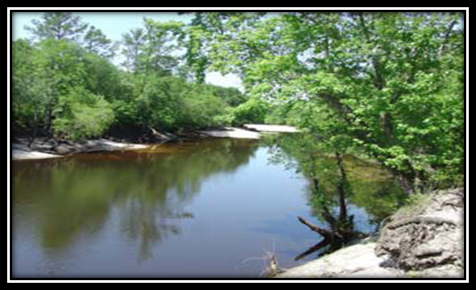

Areas of Significant Natural and Cultural Resources

GA 121 – from Folkston city limits south to the Florida border.

This area has been experiencing a significant amount of cross-border development from Florida. Even though development slowed during the recession, it is anticipated that development pressures on this area will increase again in the future, resulting in additional pressure and potential impacts on the adjacent St. Mary’s River corridor.

SGRC planning staff has worked with the City of Folkston to revise and update its land development regulations and is assisting Charlton County through development of supplemental standards which are designed to address these issues. No recent changes have been observed that would require amendments to this ARSA.

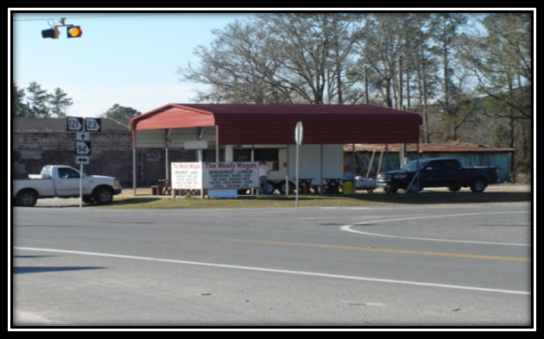

Areas of Rapid Development

Douglas Perimeter.

The area surrounding the perimeter road around Douglas in Coffee County has seen rapid development over the past several years. As the city and the county seek to continue to develop the area, the negative impacts of rapid development will need to be mitigated.

SGRC has recently worked with the City of Douglas and is working with Coffee County to develop and implement revised and new Land Development Standards and Urban Redevelopment Plans which will address these development issues including a PUD development to the airport property. No recent changes have been observed that would require amendments to this ARSA.

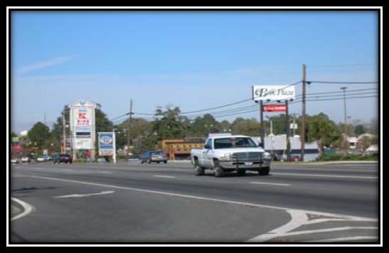

Areas of Rapid Development

Bacon County Blueberry Plantation.

This area west of Alma is a multifaceted character area that includes an adjoining airport, an 18-hole golf course, a rapidly growing residential area, and the home of the new Blueberry Plantation. This area will likely continue to develop.

No recent changes have been observed that would require amendments to this ARSA. SGRC Economic Development staff is providing technical assistance to local Economic Development staff for appropriate marketing efforts.

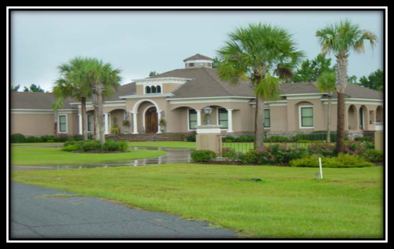

Areas of Rapid Development

Ben Hill County Airport/Industrial Area and South Corridor.

The new industrial park, the local airport, and recent commercial development along Business Route 107 have created a development-friendly environment where future growth is encouraged. This area will likely continue to develop over the planning period.

No recent changes have been observed that would require amendments to this ARSA.

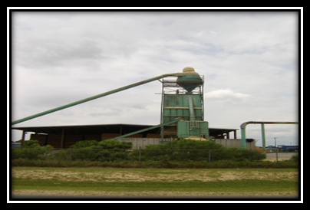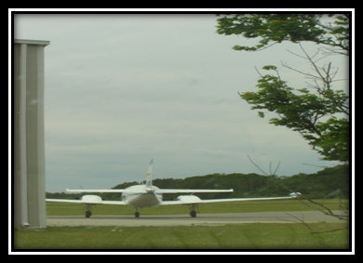

Areas of Rapid Development

Troupeville Community.

This area in eastern Brooks County is adjacent to Lowndes County, and has a direct connection to one of the major commercial corridors of the City of Valdosta. Subsequently, new commercial activity and residential growth have continued in this portion of Brooks County in spite of the County’s overall population decline. This is an area where typical suburban residential subdivision development has occurred.
No recent changes have been observed that would require amendments to this ARSA. This area of Brooks County has been included in the MPO and will now be included in regional transportation planning efforts, including the new Long Range Transportation Plan.

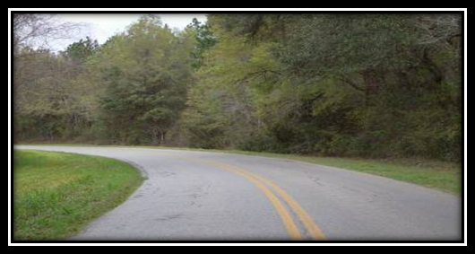

Areas of Rapid Development

Western Lanier County/Banks Lake NWR.

Of all the counties in the region, Lanier County has seen the greatest population increase between the 2000 and 2010 census counts (39 percent). The great majority of this growth has occurred in Western Lanier County and along the north shore of Banks Lake NWR. It is expected that this area will continue to grow with residential development within the next five years, as property values, good schools, and a close proximity to Moody AFB draw more and more people.

No recent changes have been observed that would require amendments to this ARSA, however, SGRC is working with Lanier County to address appropriate land use changes to ensure compatibility with Moody Air Force Base under the Joint Land Use Study Implementation Program. Lanier County has just recently adopted its Moody Air Force Base Overlay Zone Ordinance and a Memorandum of Agreement. The new MAFB Overlay Ordinance is incorporated into Greater Lanier County’s most recent comprehensive plan (due date 6/2016).

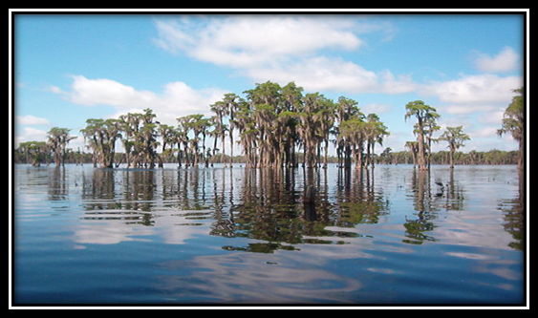

Areas of Rapid Development

Downtown Waycross.

Within the downtown area of the City of Waycross, many older and historic buildings are slowly deteriorating, and are in need of redevelopment and/or rehabilitation. The City is focusing on continuing the renovation and rehabilitation of these historic buildings, and is looking into creative new uses and mixed uses that will include residential, commercial, and office uses in the area to encourage a vibrant, livable, walkable downtown.

No recent changes have been observed that would require amendments to this ARSA. The City of Waycross Downtown Development Authority is actively marketing and assisting in the redevelopment of the Downtown. The current draft comprehensive plan for Greater Ware County is recognizing the need for additional incentives and standards for Downtown and is initiating an intergovernmental redevelopment effort.

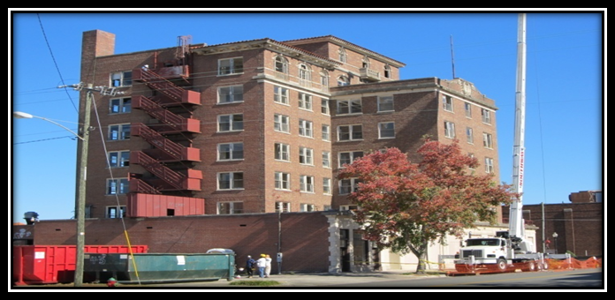

Areas of Significant Disinvestment

Oak Park Deterioration.

The Oak Park area of unincorporated Coffee County contains a large stock of mobile homes. The area is noted for its high concentration of poverty and substandard housing. The County recently completed phase two of the development of a public water system for Oak Park, as part of a series of recommendations established in the 2004 Oak Park Redevelopment Plan. Despite these major improvements, the area lacks sewer service and a paved road system. Health and environmental concerns are rampant in the area.

No recent changes have been observed that would require amendments to this ARSA. SGRC is working with Coffee County to create an opportunity zone for this area in order to provide necessary infrastructure improvements such as water, sewer, roads, and infill development. SGRC is also providing technical assistance to Coffee County in the revision of its Land Development Code, which will provide further implementation guidance to revitalize this neighborhood. The new Land Development Code has now been adopted and in step with its comprehensive plan is expected to assist in the revitalization.

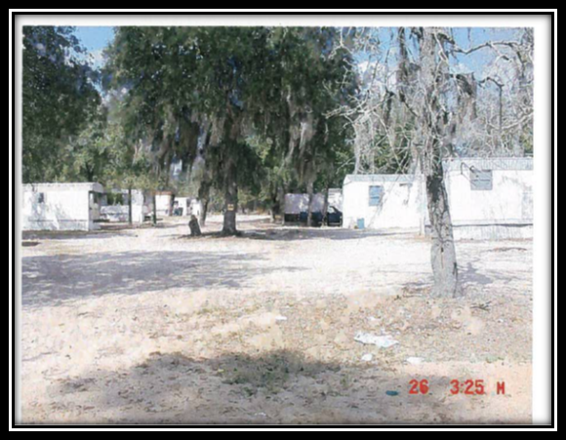

Military Installation – Moody Air Force Base and Surrounding Area

Moody Activity Area.

Located in northeastern Lowndes County near the borders with Lanier and Berrien County, the Moody Air Force Base (MAFB) is home to the Air Force’s 23rd Wing and trains and employs over 6,000 military and civilian personnel. The presence of MAFB within the area has led to continual growth and development, and resulted in over $440 million in local economic impact. As a result, it is anticipated that the area surrounding the base will continue to grow and develop, presenting planning and growth management challenges to each of the local communities. A Joint Land Use Study has been completed, which identifies local issues and impacts, recommends new policies, projects, and management techniques, and provides model ordinances and agreements to address these issues.

No recent changes have been observed that would require amendments to this ARSA. SGRC is continuously working with MAFB and the surrounding five counties to address any compatibility issues as part of the MAFB Joint Land Use Study and its subsequent implementation phases. Lanier County has adopted its MAFB Overlay Zone Ordinance and Lowndes County has also revised its MAZ’s within its Land Development Regulations. SGRC is now working with Berrien County to do the same.

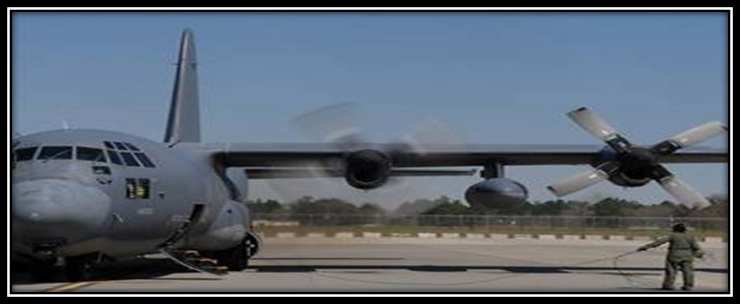

Evaluation and Monitoring
The Southern Georgia Regional Commission has developed a list of activities to evaluate and monitor the effectiveness of the Regional Plan in order to ensure the Plan is successfully accomplishing the desired results. Specific evaluation and monitoring activities include:
- Conduct bi-annual Performance Standard evaluations with local governments throughout the year. These bi-annual evaluations not only determine if local governments are achieving the minimum standard, but also assess the local governments’ progress toward implementation of the Regional Plan and their own Local Comprehensive Plan. This year the evaluations so far have been completed with Irwin, Lowndes, Berrien, Brooks and Lanier Counties and their local communities. Where deficiencies existed, efforts have been undertaken through intergovernmental assistance to remedy the deficiencies. The individual evaluations have been included on page XX. If a need arises, SGRC also schedules continuing education workshops/classes, either through in-house staff or in cooperation with other appropriate organizations.
- Regularly meet with local and regional stakeholders to survey and assess needed changes or modifications to the Regional Plan and Local Comprehensive Plans. These stakeholders include, but are not limited to, local and regional staff and elected/appointed officials, Boards of Education, Development Authorities, Chambers of Commerce, individual businesses and residents.
- Annually, in conjunction with the Regional Work Program update, the Southern Georgia Regional Commission staff develops a Report of Accomplishments (ROA) examining each activity to determine current status. The report of accomplishments for FY 2015 – 2019 is included in this report.

Evaluation & Monitoring Activities from July 1, 2015 to Present
SGRC bi-annually evaluates each local government’s compliance with the Regional Commission’s minimum Performance Standards as outlined in the most recent Regional Plan, and with the Standards of Excellence if applicable. Regional Leaders and other stakeholders are individually surveyed regarding the achievements of the minimum standards and deficiencies as well as successes and necessary further actions. The results of the evaluations for each local government are shown on the subsequent pages. One of the predominant issues is the need for additional planning and zoning training for elected and appointed officials and staff. SGRC has worked with Carl Vinson at the Institute of Government to offer Planning and Zoning 101 and 201 in April for the Southern Georgia Region. The respective projects are included as line items in the Regional Work Program. Other issues are the lack of speed and reliability in Broadband coverage for the Region. Many local government leaders feel that the Southern Georgia Region will not be competitive unless sufficient and reliable broadband coverage is provided.
All the local governments, economic development organizations, and other agencies within the region are visited to determine whether the Regional Plan and local Comprehensive Plans are effectively implemented and to determine which further actions can be taken to more effectively implement local and regional strategies. A list of visits is included in the following pages. The results from these visits are included in the updated regional work program in the form of new projects designed to further the Region’s quality of life and performance. Leaders overall have indicated that the Regional Plan is effective, is on target, and serves the region well.
As part of site visits and assessment meetings with local governments, agencies, and regional leaders, recent changes and developments which would affect the Regional Plan are researched and discussed. A review of the Regional Plan as adopted in April 2013 has not revealed any recent changes or developments which have not effectively been addressed in the current Regional Plan.

3 year Evaluation & Monitoring of Local Government Performance Measures
This section presents the results of the local governments’ Performance Measures evaluations over the last 3 years since their adoption in the 2012 Regional Plan.
At this point all local governments within the Southern Georgia Regional Commission geographical area have participated in assessment meetings during which local government performance measures are discussed and evaluated. The results of the monitoring indicate that all reporting governments are meeting the performance measures as adopted in the Regional Plan. The performance measures were developed and adopted originally to enable all communities, even the smaller, rural communities, to achieve the performance measures within two years of adoption of the plan, and where deficiencies existed, to be able to work towards eliminating those efficiencies. With this goal in mind, all SGRC communities at this point have achieved minimum ranking. Several of the larger communities are now moving on to achieve various Standards of Excellence as adopted in the Regional Plan. The next update of the Regional Plan will consider revising the Minimum Standards to raise the bar of achievement within the Region.

Local Government Performance Measure Status Report (3 yrs.)

2015 Irwin County & City of Ocilla Implementation Assessment Meeting – Achievement of Minimum Standards (Regional Plan Implementation Program) 7/28/2015
Minimum Standards | Irwin County | Ocilla
1. All uncertified elected City and County Officials must obtain minimum certification within three years of adoption of Regional Plan by Regional Commission through UGA Carl Vinson Institute or an equivalent Certification Program. | Yes. Just one is uncertified and will be by end of year | Yes, ongoing
2. All County and City Clerks obtain certification through UGA Carl Vinson Institute or equivalent Certification Program. | No, in progress | Yes
3. All Planning Commissioners attend planning commission training within one year of appointment. | In progress
4. Update the Service Delivery Strategy (SDS) as required by law with all service agreements in place and on file for public review. | Yes | Yes
5. Update and adopt the Pre-Disaster Mitigation Plan | Yes
6. Upgrade all electronic communication capabilities for effective electronic communication between all local governments and furnish appropriate training in the use. | Yes | Yes
7. Develop, update, maintain and implement zoning standards or land development regulations. | Yes | Yes
8. Develop, update, maintain and implement at a minimum the mandatory building codes and fire codes including applicable administrative procedures. | Yes | Yes
9. Put a program in place to require that all building inspections be done by a Building Inspector, who, at a minimum, has been certified through the Building Official's Association of Georgia. | Yes | Yes
10. Participate in Joint Comprehensive Planning including development of Short Term Work Programs | Yes | Yes
11. Annually perform an internal update the local Short Term Work Programs in coordination with SGRC. | Yes | Yes
12. Active participation in Best Practices Workshops, joint comprehensive planning meetings including STWP updates, training sessions offered by the SGRC. | Yes | Yes
Achieved Minimum Standards | Yes | Yes

2015 Lowndes County & Cities of Dasher, Hahira, Lake Park, Remerton, and Valdosta Implementation Assessment Meeting – Achievement of Minimum Standards (Regional Plan Implementation Program) 08/28/2015
Minimum Standards | Lowndes County | Dasher | Hahira | Lake Park | Remerton | Valdosta
1. All uncertified elected City and County Officials must obtain minimum certification within three years of adoption of Regional Plan by Regional Commission through UGA Carl Vinson Institute or an equivalent Certification Program. | Yes | Yes | Yes | Yes | Yes | Yes
2. All County and City Clerks obtain certification through UGA Carl Vinson Institute or equivalent Certification Program. | Yes | Yes | Yes | Yes | Yes | Yes
3. All Planning Commissioners attend planning commission training within one year of appointment. | Yes | Yes | Yes | Yes | Yes | Yes
4. Update the Service Delivery Strategy (SDS) as required by law with all service agreements in place and on file for public review. | Yes | Yes | Yes | Yes | Yes | Yes
5. Update and adopt the Pre-Disaster Mitigation Plan | Yes | Yes | Yes | Yes | Yes | Yes
6. Upgrade all electronic communication capabilities for effective electronic communication between all local governments and furnish appropriate training in the use. | Yes | Yes | Yes | Yes | Yes | Yes
7. Develop, update, maintain and implement zoning standards or land development regulations. | Yes | Yes | Yes | Yes | Yes | Yes
8. Develop, update, maintain and implement at a minimum the mandatory building codes and fire codes including applicable administrative procedures. | Yes | Yes | Yes | Yes | Yes | Yes
9. Put a program in place to require that all building inspections be done by a Building Inspector, who, at a minimum, has been certified through the Building Official's Association of Georgia. | Yes | Yes | Yes | Yes | Yes | Yes
10. Participate in Joint Comprehensive Planning including development of Short Term Work Programs | Yes | Yes | Yes | Yes | Yes | Yes
11. Annually perform an internal update the local Short Term Work Programs in coordination with SGRC. | Yes | Yes | Yes | Yes | Yes | Yes
12. Active participation in Best Practices Workshops, joint comprehensive planning meetings including STWP updates, training sessions offered by the SGRC. | Yes | Yes | Yes | Yes | Yes | Yes
Achieved Minimum Standards | Yes | Yes | Yes | Yes | Yes | Yes
2015 Berrien County & Cities of Alapaha, Enigma, Nashville, and Ray City
Implementation Assessment Meeting – Achievement of Minimum Standards
(Regional Plan Implementation Program) 09/22/2015
Minimum Standards | Berrien County | Alapaha | Enigma | Nashville | Ray City
1. All uncertified elected City and County Officials must obtain minimum certification within three years of adoption of Regional Plan by Regional Commission through UGA Carl Vinson Institute or an equivalent Certification Program. | Yes | Yes | Yes | Yes | Yes
2. All County and City Clerks obtain certification through UGA Carl Vinson Institute or equivalent Certification Program. | Yes | Yes | Yes | Yes | Yes
3. All Planning Commissioners attend planning commission training within one year of appointment. | Yes (some are trained, others in process of training)
4. Update the Service Delivery Strategy (SDS) as required by law with all service agreements in place and on file for public review. | Yes | Yes | Yes | Yes | Yes
5. Update and adopt the Pre-Disaster Mitigation Plan | Yes | Yes | Yes | Yes | Yes
6. Upgrade all electronic communication capabilities for effective electronic communication between all local governments and furnish appropriate training in the use. | Yes | Yes | Yes | Yes | Yes
7. Develop, update, maintain and implement zoning standards or land development regulations. | Yes | Yes | Yes | Yes | Yes
8. Develop, update, maintain and implement at a minimum the mandatory building codes and fire codes including applicable administrative procedures. | Yes | Yes | Yes | Yes | Yes
9. Put a program in place to require that all building inspections be done by a Building Inspector, who, at a minimum, has been certified through the Building Official's Association of Georgia. | Yes | Yes | Yes | Yes | Yes
10. Participate in Joint Comprehensive Planning including development of Short Term Work Programs | Yes | Yes | Yes | Yes | Yes
11. Annually perform an internal update the local Short Term Work Programs in coordination with SGRC. | Yes | Yes | Yes | Yes | Yes
12. Active participation in Best Practices Workshops, joint comprehensive planning meetings including STWP updates, training sessions offered by the SGRC. | Yes | Yes | Yes | Yes | Yes
Achieved Minimum Standards | Yes | Yes | Yes | Yes | Yes
2015 Brooks County and the Cities of Barwick, Morven, Quitman, and Pavo
Implementation Assessment Meeting – Achievement of Minimum Standards
(Regional Plan Implementation Program) 12/10/2015
Minimum Standards | Brooks County | Barwick | Morven | Quitman | Pavo
1. All uncertified elected City and County Officials must obtain minimum certification within three years of adoption of Regional Plan by Regional Commission through UGA Carl Vinson Institute or an equivalent Certification Program. | Yes | Yes | No | Yes | Yes
2. All County and City Clerks obtain certification through UGA Carl Vinson Institute or equivalent Certification Program. | Yes | Yes | Yes | Yes | Yes (in process)
3. All Planning Commissioners attend planning commission training within one year of appointment. | Yes
4. Update the Service Delivery Strategy (SDS) as required by law with all service agreements in place and on file for public review. | Yes | Yes | Yes | Yes | Yes
5. Update and adopt the Pre-Disaster Mitigation Plan | Yes | Yes | Yes | Yes | Yes
6. Upgrade all electronic communication capabilities for effective electronic communication between all local governments and furnish appropriate training in the use. | Yes | Yes | Yes | Yes | Yes
7. Develop, update, maintain and implement zoning standards or land development regulations. | Yes | No | No | Yes | No
8. Develop, update, maintain and implement at a minimum the mandatory building codes and fire codes including applicable administrative procedures. | Yes | No | Yes | Yes | No
9. Put a program in place to require that all building inspections be done by a Building Inspector, who, at a minimum, has been certified through the Building Official's Association of Georgia. | Yes | No | Yes | Yes | No
10. Participate in Joint Comprehensive Planning including development of Short Term Work Programs | Yes | Yes | Yes | Yes | Yes
11. Annually perform an internal update the local Short Term Work Programs in coordination with SGRC. | Yes | Yes | Yes | Yes | Yes
12. Active participation in Best Practices Workshops, joint comprehensive planning meetings including STWP updates, training sessions offered by the SGRC. | Yes | Yes | Yes | Yes | Yes
Achieved Minimum Standards | Yes | Yes | Yes | Yes | Yes
2016 Lanier County & City of Lakeland
Implementation Assessment Meeting – Achievement of Minimum Standards
(Regional Plan Implementation Program) 01/11/2016
Minimum Standards | Lanier County | Lakeland
1. All uncertified elected City and County Officials must obtain minimum certification within three years of adoption of Regional Plan by Regional Commission through UGA Carl Vinson Institute or an equivalent Certification Program. | Yes | Yes
2. All County and City Clerks obtain certification through UGA Carl Vinson Institute or equivalent Certification Program. | Yes | Yes
3. All Planning Commissioners attend planning commission training within one year of appointment.
4. Update the Service Delivery Strategy (SDS) as required by law with all service agreements in place and on file for public review. | Yes | Yes
5. Update and adopt the Pre-Disaster Mitigation Plan | Yes | Yes
6. Upgrade all electronic communication capabilities for effective electronic communication between all local governments and furnish appropriate training in the use. | Yes | Yes
7. Develop, update, maintain and implement zoning standards or land development regulations. | Yes | Yes
8. Develop, update, maintain and implement at a minimum the mandatory building codes and fire codes including applicable administrative procedures. | Yes | Yes
9. Put a program in place to require that all building inspections be done by a Building Inspector, who, at a minimum, has been certified through the Building Official's Association of Georgia. | Yes | Yes
10. Participate in Joint Comprehensive Planning including development of Short Term Work Programs | Yes | Yes
11. Annually perform an internal update the local Short Term Work Programs in coordination with SGRC. | Yes | Yes
12. Active participation in Best Practices Workshops, joint comprehensive planning meetings including STWP updates, training sessions offered by the SGRC. | Yes | Yes
Achieved Minimum Standards | Yes | Yes

Local Government/Stakeholder Survey-Interview-Visit Dates

Jurisdiction | Date
Brooks County | 6/1/2015
Dasher | 6/1/2015
Turner County | 6/5/2015
Clinch County | 6/8/2015
Lanier County | 6/8/2015
Cook County | 6/9/2015
Tifton | 6/9/2015
Douglas | 6/11/2015
Ben-Hill | 6/11/2015
Alma | 6/23/2015
Turner County | 6/23/2015
Clinch County | 6/24/2015
Turner County | 6/25/2015
GMA | 6/27/2015
Brantley County | 7/7/2015
Ocilla | 7/8/2015
Waycross | 7/10/2015
Pearson | 7/13/2015
Douglas | 7/15/2015
Folkston | 7/20/2015
Fitzgerald | 7/21/2015
Darien (CAC) | 7/23/2015
Cook | 7/24/2015
TyTY, Omega | 7/27/2015
Berrien | 8/4/2015
Macon, (GARC) | 8/6/2015
Fitzgerald | 8/7/2015
Hahira | 8/10/2015
Sparks | 8/14/2015
Brantley | 8/19/2015
Lowndes | 8/20/2015
Enigma | 8/21/2015
Irwin, Ocilla | 8/24/2015
Pearson | 8/24/2015
Coffee/ Bacon | 9/3/2015
Savannah (GPA) | 9-(9,10,11)-15
Dasher | 9/15/2015
Ben-Hill | 9/16/2015
Homerville | 9/18/2015
Tifton, Douglas | 9/21/2015
Pavo | 9/29/2015
Brantley | 10/2/2015
Brooks County | 10/5/2015
Jekyll Island ( ACCG) | 10/8/2015
Adel | 10/19/2015
Lake Park | 10/13/2015
Cook County ( Legislature Mtg.) 10-14-15 | 12/2/2014
Midway (CAC) | 10/20/2015
Quitman | 10/21/2015
Lanier/ Lakeland | 10/22/2015
Tifton ( ACCG) | 10/27/2015
Lake Lanier (city/county managers 10-(28,29,30)15 | 10-28-30-15
ST Simons (GARC) | 11-4-6-15
Lanier | 11/9/2015
Waycross | 11/12/2015
Pearson | 11/16/2015
Brooks Co. (P/C) | 11/17/2015
Nashville ( GMA) | 11/19/2015
Barwick, Pavo, Morven | 11/30/2015
Quitman. Brantley Co. | 12/1/2015
Turner County | 12/3/2015
Brooks ( C/C mtg) | 12/7/2015
Nashville (Clerks mtg) | 12/9/2015
Pearson ( Board Mtg) | 12/10/2015
Lanier | 12/14/2015
Ocilla, Irwin | 12/16/2015
Fitzgerald | 12/28/2015
Coffee | 1/4/2016
Valdosta/Lowndes | 1/6/2016
Atlanta ( Legislature Supper) | 1/13/2016
Adel | 1/19/2016
Alma, Nichols | 1/21/2016
Lake Park | 1/25/2016
Macon,(ED PROs mtg) | 2/10/2016
Pearson, Tifton | 2/15/2016
Ambrose | 2/17/2016
Tifton | 2/18/2016
Quitman | 2/22/2016
Folkston | 2/23/2016
Adel, Tifton | 2/25/2016

For Further Information or Questions, Please contact:

Julia Shewchuk, AICP, 229-333-5277 jshewchuk@sgrc.us
Or
Ariel Godwin, AICP, 229-333-5277
agodwin@sgrc.us

