Valdosta-Lowndes MPO

Electric Vehicle Infrastructure

Readiness Strategy

for Small Cities and Rural Areas

in Southern Georgia

Valdosta-Lowndes MPO

Electric Vehicle Infrastructure

Readiness Strategy

for Small Cities and Rural Areas

in Southern Georgia

Adopted June X, 2022
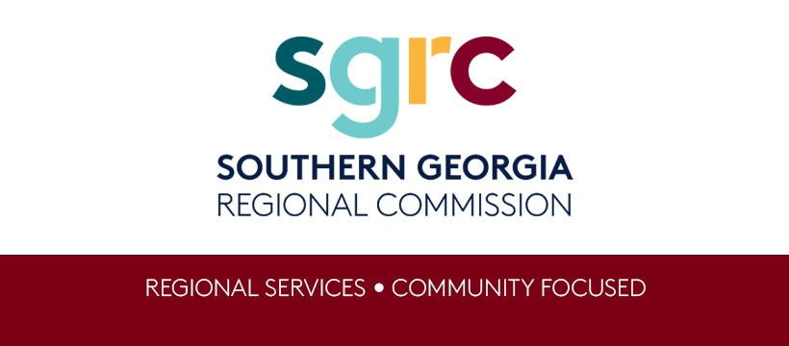
Southern Georgia Regional Commission | Valdosta-Lowndes Metropolitan Planning Organization
1937 Carlton Adams Drive
Valdosta, Georgia 31601
229-333-5277
www.sgrc.us
The contents in this publication reflect the views of the author(s), who is (are) responsible for the facts and accuracy of the data presented herein. The opinions, findings, and conclusions in this publication are those of the author(s) and do not necessarily reflect those of the Department of Transportation, State of Georgia, the Federal Highway Administration, or the Federal Transit Administration. This publication does not constitute a standard, specification or regulation.
The Southern Georgia Regional Commission as designated MPO for the Valdosta Urbanized Area provides staff and programmatic support for the VLMPO and is an Equal Opportunity Employer and Service Provider. Qualified persons are considered for employment or for receipt of services without regard to race, color, religion, sex, sexual orientation, national origin, age, or disability.
This document is prepared in cooperation with the Georgia Department of Transportation, the Federal Highway Administration and Federal Transit Administration.
The Southern Georgia Regional Commission as the designated MPO for the Valdosta Urbanized Area ensures that all VLMPO products and programs fully complies with Title VI of the Civil Rights Act of 1964 and related statutes and regulations in all programs and activities. SGRC’s website (www.sgrc.us) may be translated into multiple languages. Publications and other public documents can be made available in alternative languages or formats, if requested.

Adoption Resolution
Insert adoption resolution here

Table of Contents
Adoption Resolution 3
Table of Contents 4
Introduction 5
VLMPO EV Strategy Benefits 9
VLMPO EV Strategy Goals and Objectives 11
Existing and Future Conditions Analysis 14
EV Charging Infrastructure Deployment 14
Implementation Considerations 16
Program Evaluation 17
Appendix 18

Introduction
Electric vehicles (EV) have been discussed for many decades as the future propulsion choice for motor vehicles both in the United States and throughout the world. The technology behind EVs has been developed to a point where it is now much more cost effective to mass-produce vehicles for use by the general consumer to provide cost effective, daily transportation.
“The Alternative Fuels Data Center shows a 70% reduction in annual emissions from gasoline-powered vehicles to electric vehicles. The estimate includes well-to-wheel emissions, or all emissions related to fuel production, processing, distribution, and use.” While emissions have traditionally not been a major concern in South Georgia, there is general support for cleaner fuel sources for both power generations as well as transportation. It is this general support that is driving both a national and global shift for automakers to produce more EVs for the consumer market that will require new and expanded EV charging infrastructure as well as a reduction in gasoline fuel infrastructure (ex: gas stations) over time.
As a small Metropolitan Planning Organization, the Valdosta-Lowndes community often thinks of itself as a large rural community – in fact, it is the economic center of an 18-county region that is served by the Southern Georgia Regional Commission, which is the designated MPO for the Valdosta urban area. This report will focus on how a small metropolitan area can set an example for surrounding rural areas to develop EV charging infrastructure that will help these communities access amenities in the surrounding metro areas like Valdosta.
The primary motivation for this report is to outline the goals and objectives necessary for Valdosta and surrounding rural areas to be ready to implement EV charging infrastructure policies, programs, and projects ahead of any broad need from the travelling public. By putting in place new regulations and programs early communities like Valdosta can be ready to access new funding opportunities and attract private investment related to EV infrastructure, and transition the local economy from one based on gasoline powered motor vehicles to one based on EVs in an effort to improve overall economic development of the region.
This EV Strategy is being developed at the same time as the State of Georgia EV Charging Infrastructure Plan and that federal regulations and guidance are being developed for funding programs for EV infrastructure. Therefore, this strategy focuses on the tasks that local governments need to complete as well as local policies and programs in order for local governments to be competitive for future federal funding as well as private investment in EV charging infrastructure.

Fundamentals of EV Charging Infrastructure
There are three types of chargers available to the EV market. Level 1 chargers use typical 110-volt household AC circuit at a rate of about 5 miles driving range per hour (RPH) charging time.
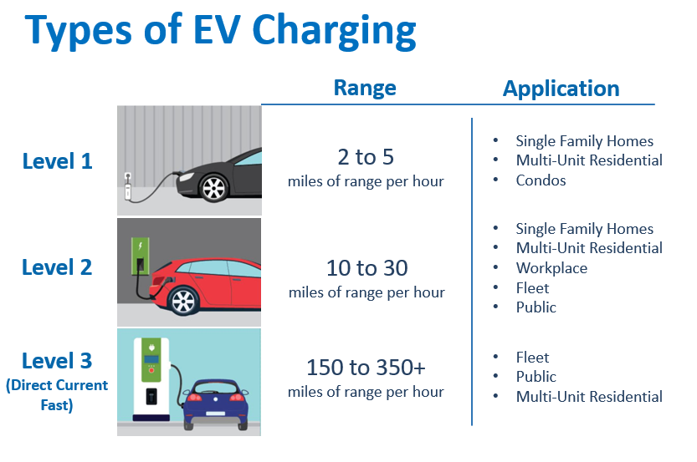
Level 2 chargers employ a 240-volt household circuit that are good for overnight charging at home or for locations where a car will be plugged in for a while (ex: work, theater, etc.). These chargers will by what most EV owners will use to charge when they are using a vehicle for most daily activities (ex: commuting, shopping) etc.
The third type, 150kW Direct Current (DC) Fast Chargers, are typically publicly accessible and can charge a battery in 30 minutes or so (depending on many factors) and will have the ability to charge multiple vehicles at once. This is the standard charger that is a part of the National Electric Vehicle Infrastructure (NEVI) Formula Program. These chargers facilitate mobility across states and the nation.
This report will focus on what local governments can do to facilitate the installation of Level 2 and 3 Chargers by either public agencies, the private sector, and/or public-private partnerships.

EV Strategy Workshop
On December 1, 2021, the VLMPO Policy Committee hosted a regional EV infrastructure goal setting workshop. The event was facilitated by Whitney Shepard with Transport Studio and included a panel of experts on federal and state EV strategy and was followed by discussion of impacts, issues, and opportunities in the region. In addition to VLMPO committee members and staff from regional jurisdictions, attendees included representatives from the GA Public Service Commission, Clean Cities-Georgia, Georgia Power, Georgia Transmission, and Georgia EMCs.
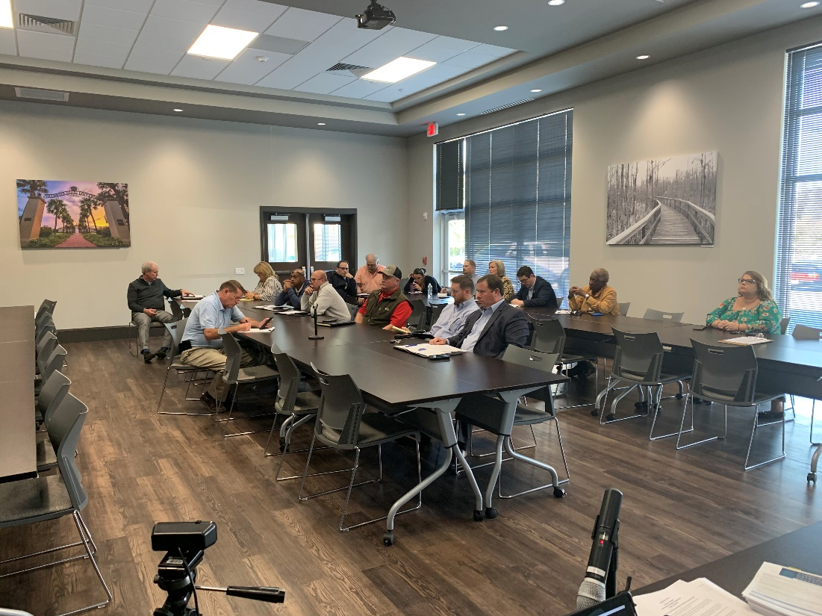
The discussion highlighted the goals of increasing economic development, ensuring energy efficiency and security, improving air quality and public health, as well as a positive public image for the region. Topics of discussion included EV battery life and future use or recycling of old batteries, impacts of natural disasters on the electric grid, the need for education on new technologies, the importance of rural investments in EV infrastructure, opportunities for federal funding, investment strategies from public and private entities (like GA Public Service Commission, Georgia Power, etc.), and how developing an EV strategy can support local comprehensive planning.
After the event, Transport Studio prepared an EV Infrastructure Planning Framework that has led to the development of this EV Infrastructure Strategy. This Framework report is available on the website at www.sgrc.us.

EV Infrastructure Investment in Georgia
In July 2021, Governor Brian Kemp announced the creation of the Georgia Electric Mobility and Innovation Alliance (EMIA), led by the Georgia Department of Economic Development as a statewide initiative between government, industries, electric utilities, non-profits, and other stakeholders. EMIA is focused on growing the electric mobility ecosystem in Georgia through manufacturing and innovation.
The Georgia Department of Transportation has accelerated the support of for installing EV Charging Infrastructure through the designation of ten highway corridors as being EV ready through the National Alternative Fuels Corridor initiative. I-75 in Valdosta is included in this initiative and there are already DC Fast Charges located along this route (some are restricted to Tesla vehicles only).
Local governments in Southern Georgia are fortunate to be in a state that is a leader in future mobility technologies and innovation with resources like The Ray Intelligent Highway, autonomous vehicle testing, and smart traffic signal systems like those in Valdosta. The VLMPO is leading local governments to consider connected and autonomous vehicle needs that include the shift to EVs that are also connected and autonomous. Local governments in Southern Georgia need to take advantage of resources from state agencies and their position relative to other EV-related manufacturing and innovation companies to enhance their own economic development efforts.

Public Engagement
This EV Strategy was first presented to the VLMPO Committees in March 2021 as an overview of the document without a presentation by staff. Upon completion of the draft, it was made available for public comments and input from stakeholders in April and May 2022. The comment period included social media posts, and emails sent to VLMPO stakeholders asking for comments. In June 2022, the final document was presented to the VLMPO committees and an adoption resolution was passed. Copies of comments received during the comment period are included in the appendix.

National EV Policy
While EVs have been available to consumers for several years, the public EV charging infrastructure has been slower to develop. The Infrastructure Investment and Jobs Act (IIJA) passed by Congress in November 2021 provides the funding to begin to create a nationwide, publicly accessible EV charging infrastructure network that can readily improve mobility for all EV users who have been previously prevented from travelling greater distances due to the limited range of vehicles or available charging infrastructure.
The US Department of Transportation and Energy created a joint office to align resources across the federal government to implement this national EV charging network through shared knowledge and funding resources made available to states and local governments. The initial priorities of this joint office include:
- The accelerated adoption of EVs including those that cannot readily charge at home to enable up to 50% of new vehicles sales to be electric by 2030.
- Reduce transportation-related emissions to be on a path for the United States to be net-zero emissions by 2050.
- Create high-paying jobs to manufacture and service EVs and their associated infrastructure.
- Targeted benefits for all populations, that promotes equity and reduces mobility and energy burdens while creating jobs and supporting businesses in both urban and rural areas.
For several years the Federal Highway Administration has worked to identify national Alternative Fuel Corridors that provide information to the travelling public on where alternative fuels (including: electric, CNG, LNG, hydrogen, LP, etc.) may be found along a route. This national EV charging infrastructure initiative will add more infrastructure to these corridors and build that infrastructure not just on Interstate highways, but on other parts of the National Highway System as well as key state and local corridors as well.
The National Electric Vehicle Infrastructure (NEVI) Formula Program provides funding for states to implement projects to build out their own networks of EV charging stations. This funding program provides 80 percent federal funds that are matched with either private or state funds to complete a project. Because the private sector already has expertise in the installation, operation, and maintenance of EV charging infrastructure the NEVI Program anticipates that most states will contract with private companies in whole or in part to build EV charging infrastructure further providing for well-paying jobs, small business and community engagement in the EV industry.

VLMPO EV Strategy Benefits
The 2021 Joint Comprehensive Plan for Lowndes County and Cities identifies the need and opportunity and policies to provide the necessary infrastructure for EV charging stations in appropriate locations. To this end, the Comprehensive Plan includes the following activities in the work program:
- Develop EV charging station model ordinance
- Complete an EV Implementation Strategy report
The VLMPO’s Vision2045 Metropolitan Transportation Plan discusses the increasing prevalence of EVs as a part of the future of transportation mobility throughout Lowndes County and surrounding areas. The Plan notes that EVs will provide efficiencies for public transit systems as well as individual users. When coupled with connected and autonomous vehicles (CAVs), EVs will change the future of mobility for everyone in the community whether they drive or not. EVs will play a bigger role in the transportation of people and the delivery of goods and services to people through CAVs (like drone delivery). Specifically, the Vision2045 MTP highlights that local governments can transition their communities to a future with EVs through the following initiatives:
- Building parking lots/decks that include electrical conduit to many parking spaces for future EV charger installation.
- Change policy for parking lots that require a minimum number of spaces to be EV charger ready (conduit installed), and install EV chargers for on-street parking on existing light poles.
- Prepare for funding opportunities from federal, state, and private sector partners.
- Convert municipal vehicle fleets to electric where appropriate to reduce costs and encourage community adoption of EVs.
- Implement programs to ensure equity for all populations to access EVs, including through the implementation of EV public transit fleets.
- Require that all new residential structures include EV charging ready electrical boxes and plugs in garages or carports.
The growing number of EVs is beneficial both nationally by reducing dependence on foreign sources of petroleum. While the US imports about 3% of petroleum consumed, the transportation sector amounts for 30% of all energy consumption and 70% of petroleum consumption. Minimizing imported petroleum and reducing overall transportation sector petroleum consumption would mean less dependence on this fuel source and increase overall resiliency of energy sources (electricity generation uses many diverse fuel sources).
While the current purchase cost of EVs tends to be higher than conventional gasoline fueled vehicles, the increases in EV production are driving down the costs of entry into the EV market by many consumers. The overall costs to fuel/charge an EV can be anywhere from one-quarter to one-half the cost of gasoline (depending on price), and other costs of annual maintenance are often lower as well. As EVs become more prevalent users will have be able to save money usually spent on gasoline.
As mentioned previously another benefit of EVs is that they typically have emissions that are 70% less than traditional gasoline fueled vehicles. While the VLMPO area and surrounding area is in attainment for national air quality standards, improved air quality in general is a positive for the overall health of people.
This EV strategy can be used as a regional economic development tool to support business growth and workforce development. Local businesses can become leaders in the installation, operation, and maintenance of EV charging infrastructure and EVs batteries and other components. Technical colleges and other institutions should develop training courses to teach future EV technologists who will be skilled in maintaining EVs and EV charging infrastructure.

VLMPO EV Strategy Goals and Objectives
The Common Community Vision for Lowndes County outlines ways for the VLMPO region to develop infrastructure programs to be “A resilient community where partnerships and coordination promote regional success in economic development, education, infrastructure, and a high quality of life.” This EV Strategy will help the VLMPO region achieve this vision by promoting overall energy conservation and expanded use of solar and other energy sources.
To help achieve this vision, this EV Strategy sets out these goals and objectives:

Goal 1: Local and Regional EV Champions and Partners

The VLMPO shall be a regional leader among local governments that forms a regional committee that identifies a local champion, partner organizations and stakeholders that can coordinate regional EV infrastructure investments.

Partner organizations may include GA Power, EMCs, Clean Cities Georgia Coalition, Development Authorities, major retail locations, schools (K-12/Colleges/Universities) major hoteliers, etc.

The VLMPO shall participate in national and state dialogues to discuss a means of funding transportation infrastructure improvements without motor fuel taxes.

Goal 2: Transportation and Comprehensive Planning; Updates to Codes, Ordinances, etc.

The VLMPO shall amend the Vision2045 Metropolitan Transportation Plan (or incorporate into next MTP update) to include EV infrastructure projects and strategies, where appropriate.

The VLMPO and SGRC shall develop basic EV infrastructure project and strategy language to include in amended local Comprehensive Plans, Regional Plans, and Comprehensive Economic Development Strategies.

The VLMPO and SGRC shall develop basic language to ensure that EV charging infrastructure is identified as critical facilities in local Hazard Mitigation Plans.

The VLMPO and SGRC shall develop a model ordinance (ex: zoning/land development) to allow and/or require new (or significant remodel) of single-family or multi-family residential, commercial, and industrial properties to be EV Charging Ready

Model ordinance should consider: historic district requirements, on-street charging, charging as an accessory use, require minimum EV parking spaces by land use, etc.)

Additional partners may include institutions (hospitals, churches, universities), GA Dept. of Community Affairs, realtors, building contractors, business owners, etc.

SGRC shall work with GA DCA to update state and local building codes to require new and/or remodeled buildings to be EV Charging Ready.

Local governments shall review and update local land permitting and building inspection processes as needed to incorporate any changes required for EV infrastructure.

Local governments shall review their cybersecurity measures for not only EV charging stations, but also other connected systems to reduce cybersecurity threats to local outages.

Goal 3: Local/Regional EV Charging Station Network

The VLMPO and SGRC shall map existing charging locations and develop an EV Suitability Map (at the tract level) using criteria specified by NEVI, focusing on those areas not on interstates.

Local need to work with MEAG cities, EMCs, and GA Power to determine if the existing electrical grid can handle EV charging

MEAG cities, EMCs, and GA Power should develop mitigation strategies in those areas where the electric grid cannot support EV charging

The VLMPO and SGRC shall work with local governments (including schools and authorities) to identify which of their fleet locations needs EV charging station investments.

Goal 4: Coordination with Businesses for EV Infrastructure Implementation

The VLMPO and SGRC’s WorkSource Southern Georgia should work with area Technical Colleges to develop career pathways to train skilled workers to repair and maintain EVs and EV Charging Infrastructure.

Goal 5: Education and Outreach for EV Charging Infrastructure

The VLMPO should consider becoming a member of the Clean Cities Georgia Coalition and other organizations that promote EV charging infrastructure as appropriate.

The VLMPO and SGRC shall develop an educational campaign to inform the public about EVs, EV Charging Stations, and their impact on South Georgia mobility, environment, and economic development.

Goal 6: First Responders, Government Fleets and EV Deployment

Local governments shall develop or enroll first responders in training programs for EV emergency response (partners include GPSTC in Forsyth, Valdosta and Lowndes FD, etc.).

Local governments shall develop policies and/or ordinances for public EV charging locations to enforce strict time limits at public and private locations to allow other cars to use EV chargers (similar to parking enforcement)

The VLMPO and SGRC shall work with local governments (including schools and authorities) to identify grant opportunities to replace gasoline powered fleet vehicles with EVs.

Existing and Future Conditions Analysis
The US Department of Energy’s Alternative Fuels Data Center Station Locator tool identifies about 17 Level 2 and DC Fast Charger locations in Southern Georgia, most of which are in Valdosta and Tifton. Most of these locations are at hotels, and existing EV car dealerships. Only one of these locations (at the Wal-Mart on Norman Drive in Valdosta) is a publicly accessible DC Fast Charger that meets the requirements of the NEVI Program. This indicates that there are opportunities for the installation of DC Fast Charging locations throughout the region to facility the improved mobility of individuals with EVs. There is also an identified need for Level 2 EV chargers throughout the region that might be installed at locations where people would be expected to spend more time with vehicles parked (examples include workplaces, casual restaurants, some retail areas, etc.).
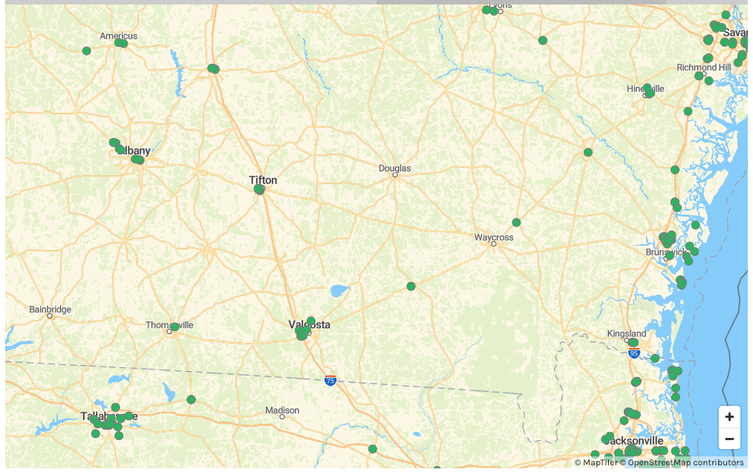

EV Charging Infrastructure Deployment
As a part of this report, the VLMPO working with the SGRC Geographic Information Systems (GIS) department looked at how suitable different areas of the entire SGRC are for future EV charging infrastructure deployments. This is important to the VLMPO because as a central, metropolitan city in Southern Georgia, many residents commute to Valdosta from surrounding counties, even those outside the local metropolitan area. In order for Valdosta to have a successful economic future with increasing numbers of electric vehicles we also need to make sure that surrounding rural areas have access to EV charging infrastructure. The map below shows the areas that are more suitable for Level 2 or Level 3 EV charging deployments throughout the region.
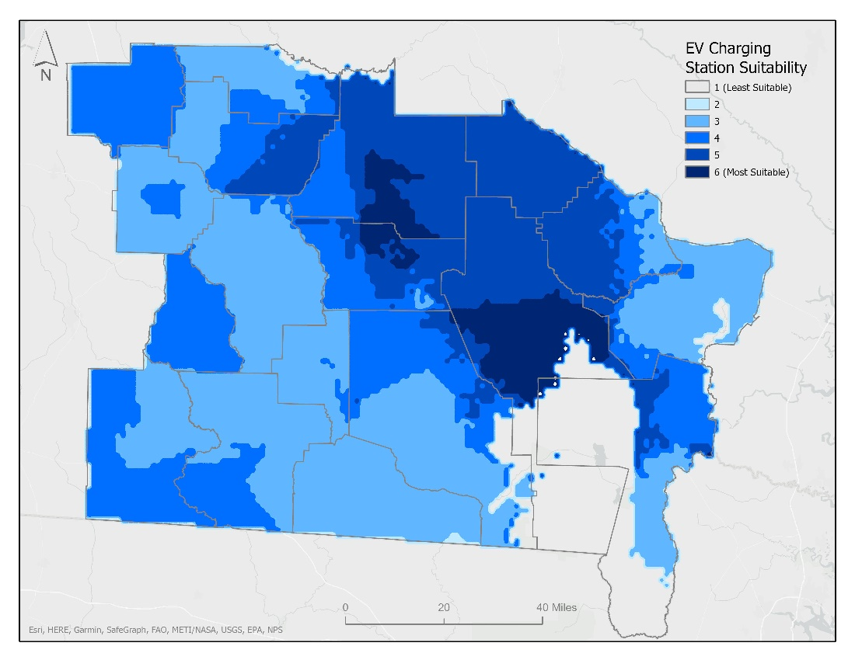
This suitability map was developed using the same or similar data and criteria modified from the NEVI state planning requirements.
The methodology used to develop this suitability map included the following data sources:
- EV Justice Tracts 40
- Alternative Fuel Corridors
- GA & FL NEVI eligible stations
- Alternative Fueling Stations
- Electric substations
- US Census Bureau 2020 Population and Designated Places
These data sources were then overlaid to create an overall weighted suitability index as follows. A full technical report of this methodology is available upon request.
- Areas more than 50 miles driving distance from existing NEVI eligible stations were identified. Areas on interstates were excluded, as states are required to by federal guidance to look at these roadways.
- Census tracts that were identified by the EV Environmental Justice 40 initiative were then identified.
- Census designated places (CDP) were identified and a 30-minute drive time from each CDP centroid was calculated. These drive time polygons were then weighted by population from the origin point to give more weight to areas that have more people.
- Areas were then identified by their distance away from existing designated Alternative Fuel corridors on a quintile scale with those being farther away receiving a higher weight.
- Each of the weighted scores in the raster layers were summed to create a map of more suitable areas for Level 2 and 3 EV charging infrastructure needs.

Implementation Considerations
As local governments work to implement EV charging infrastructure in their communities, they should work with power companies and private companies that install, own, operate, and maintain EV infrastructure to ease the burden on local governments. There are many different models of install-own-operate-maintain offered by private companies and each local government and local business will need to determine for themselves what works best for them.
The most important thing that a local government can do is to make sure their local ordinances are EV-ready, meaning that they have adopted a model ordinance to include EV vehicles and EV charging infrastructure into new development projects. While EV charging stations may not be coming to individual communities in the next six months, the private market is building quickly and even in rural areas, there will soon be a demand for EV infrastructure and local governments can get ahead of the industry now to ensure their community is EV ready.
The EV Strategy the Workshop hosted by the VLMPO and SGRC in December 2021 resulted in the identification of several local model ordinance best practices:
- Summary of Best Practices in EV Ordinances, by the Great Plains Institute
- Model Electric Vehicle Ordinance, Kane County, IL
- EV Infrastructure Zoning Amendment, Auburn Hills, MI
- Virginia EV Charging Site Design Guidelines
- Clean Cities Georgia EV Readiness Workbook
Using these and other resources with technical assistance from the VLMPO and SGRC local governments in Southern Georgia will be well positioned to welcome EVs to their communities.

Cybersecurity
As local governments work to implement EV charging infrastructure, whether on their own or in partnership with private entities, they should prioritize the cybersecurity considerations for stations to ensure that they are not compromised by malicious code. These additional considerations will require additional staff expertise and costs associated with the ongoing maintenance of the EV charging infrastructure.

Public Comments and Equity Considerations
This EV Strategy was made available for public comment in the spring of 2022. This comment period gave stakeholders, local governments, and the public the opportunity to comment on how EV charging infrastructure might be deployed in Southern Georgia. A summary of the comments received is included in the Appendix.
As a part of the deployment analysis conducted above several GIS layers were included that address disadvantaged populations that should be a priority for equitably deploying EV charging infrastructure throughout the region. As each EV charging installation is considered specific local conditions should be addressed that improve access for disadvantaged populations. Depending on the funding sources used to support the installation specific requirements may be required to address equity concerns like the Civil Rights Act, Americans with Disabilities Act, and Section 504 of the Rehabilitation act, among other state and federal laws and regulations.

Program Evaluation
The VLMPO and SGRC should reevaluate the deployment of EV charging infrastructure and the effectiveness of this Strategy for any updates that may need to be made. As with other fast changing technologies some objectives and strategies to deploy EV charging infrastructure may change faster than this Strategy or other local and regional plans can be updated. For this reason, activities included in work programs and plans should be broad enough to support EV charging infrastructure deployment and other associated strategies, but not specific enough to restrict a community from implementing a new, unforeseen technological advancement.

Appendix

VLMPO EV strategy Framework, Transport Studio, 2021: Southeast Energy Efficiency Alliance, "Electric Transportation Toolkit for Electric Membership Cooperatives," SEEA, 2020.
https://www.designnews.com/automotive-engineering/fundamentals-electric-vehicle-charging
Source: https://www.phoenix.gov/sustainabilitysite/MediaAssets/New_Types_of_Charging.png
Source: SGRC, VLMPO Workshop Attendees 12-1-21.
https://driveelectric.gov/#about-description
https://www.dca.ga.gov/sites/default/files/lowndescounty_compplan_12172021.pdf; pg. 20
https://www.dca.ga.gov/sites/default/files/lowndescounty_compplan_12172021.pdf; pg. 46
https://www.dca.ga.gov/sites/default/files/lowndescounty_compplan_12172021.pdf; pg. 54
https://www.dca.ga.gov/sites/default/files/lowndescounty_compplan_12172021.pdf; pg. 73, 78, 81, 83, 85, 89
https://www.sgrc.us/documents/transportation/visionplans/Vision2045_Metropolitan_Transportation_Plan.pdf; pg. 53
https://afdc.energy.gov/fuels/electricity_benefits.html
https://afdc.energy.gov/calc/; price per gallon used: $2.30/$4.30 and $0.12/kwh for average electricity cost
Greater Lowndes County Common Community Vision; pg. 13
https://afdc.energy.gov/stations#/find/nearest?fuel=ELEC
https://afdc.energy.gov/stations#/find/nearest?fuel=ELEC; all EV charging stations in region as of 3-16-2022
VLMPO/SGRC suitability map for EV Charging Infrastructure. Source: SGRC
https://www.fhwa.dot.gov/environment/alternative_fuel_corridors/nominations/90d_nevi_formula_program_guidance.pdf

